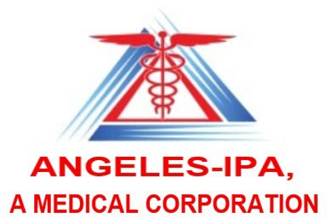

2026 Annual Training Attestation

Compliance Monitoring 2026 Training Packet(s):

Monitoring for:
1. 2026 Annual PPG Training D-SNP Care Coordination (CC) Model of Care (MOC)

The signed attestation form is due to L.A. Care Compliance DOC Communications
compliance_docommunications@lacare.org

, attest that I have reviewed the 2026 Annual PPG Training packet(s) listed above and have provided this training to the appropriate staff and departments in my organization.
A copy of the signed attestation (you can type your information below) will need to be submitted to: L.A. Care Compliance DOCommunications compliance_docommunications@lacare.org
by October 31, 2026

Signature

Print Name

Title

Organization Name

NPI #

Date

